# **Grand Cherokee (WK2) 2011-2022**

Jeep Grand Cherokee (WK2) 2011-2022 Air Suspension System has 2 Front Air Struts and 2 Rear Air Spring Bags with 2 Rear Shock Absorbers. Height Sensors tell the Control Module when the Air Suspension Compressor needs to inflate or deflate the Air Suspension System. The Solenoid Valve Block will distribute the Air accordingly throughout the Air Suspension System. Here at BAVARIA CENTER you will find many of the necessary parts and components to fix your Jeep Grand Cherokee (WK2) 2011-2022 Air Suspension System.

# **Grand Cherokee Air Spring Suspension Kit (FRONT)**

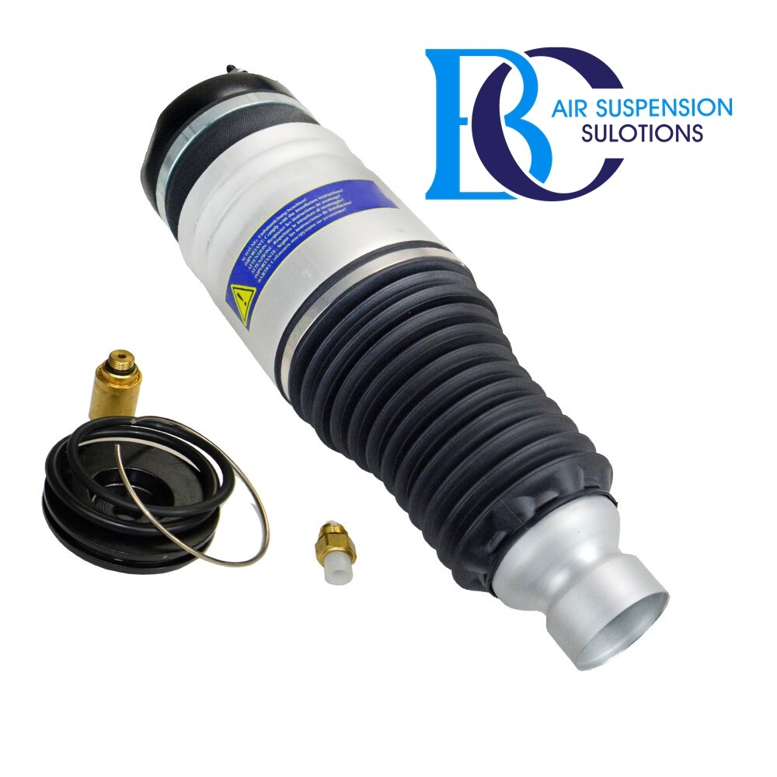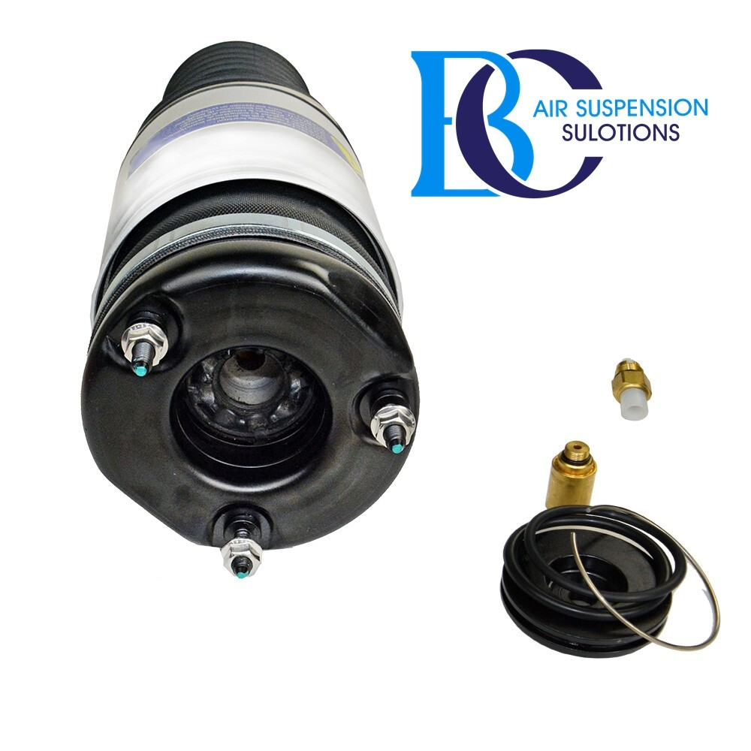

**Description**

This is a new air spring for the Jeep Grand Cherokee front side.

This is a kit for the complete suspension strut.

This kit should not be used for oil leaking shock absorbers.

**It can be installed in the following vehicles:**

JEEP GRAND CHEROKEE Limited 2011-2015

JEEP GRAND CHEROKEE Overland 2011-2015

JEEP GRAND CHEROKEE Summit 2014-2015

JEEP GRAND CHEROKEE Laredo 2011-2015

JEEP GRAND CHEROKEE W5A580 2012-2015

**OEM part numbers:**

68029903AC, 68029903AD, 68029903AE, 68059905AB, 68059905AC.

# **Jeep Grand Cherokee IV (WK2) Air suspension struts, front left**

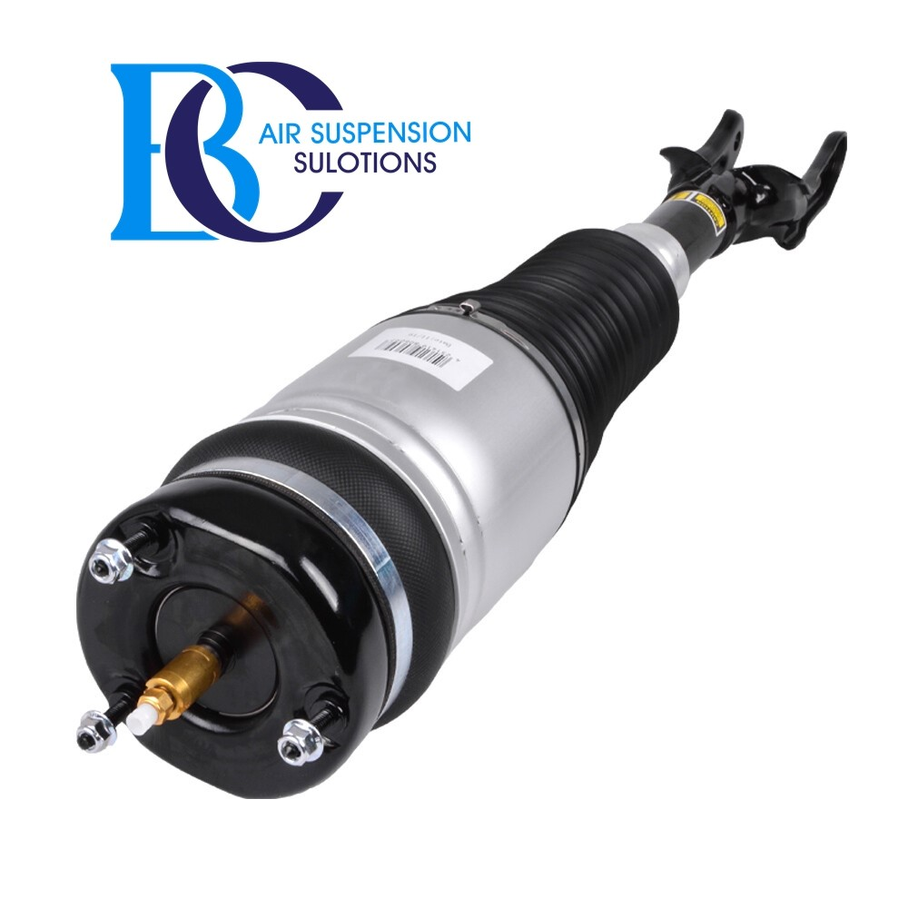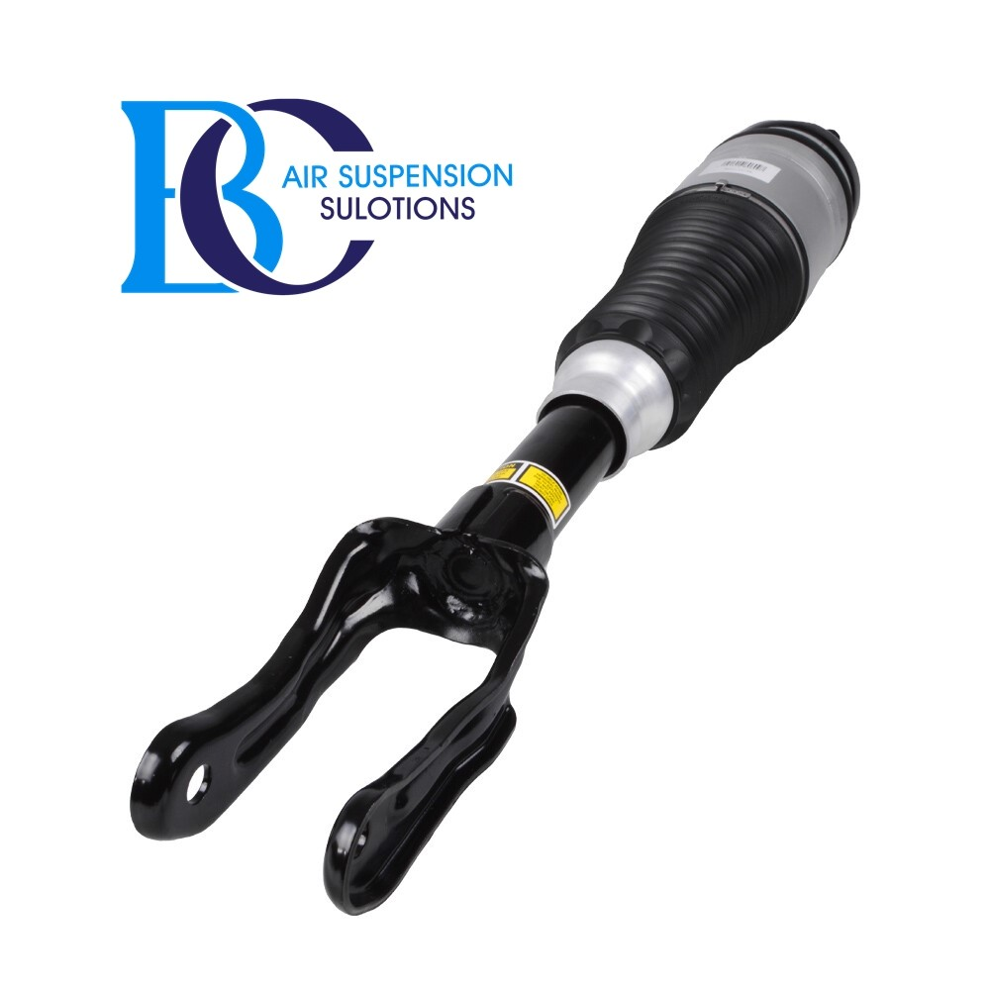

**Description**

This is a new shock absorber Air Suspension Strut front left side.

**Can be installed in the following vehicles:**

JEEP GRAND CHEROKEE Limited 2011-2015

JEEP GRAND CHEROKEE Overland 2011-2015

JEEP GRAND CHEROKEE Summit 2014-2015

JEEP GRAND CHEROKEE Laredo 2011-2015

JEEP GRAND CHEROKEE W5A580 2012-2015

**OEM part number:**

68029903AC, 68029903AD, 68029903AE, 68059905AB, 68059905AC

# **Jeep Grand Cherokee IV (WK2) Air suspension struts, front right**

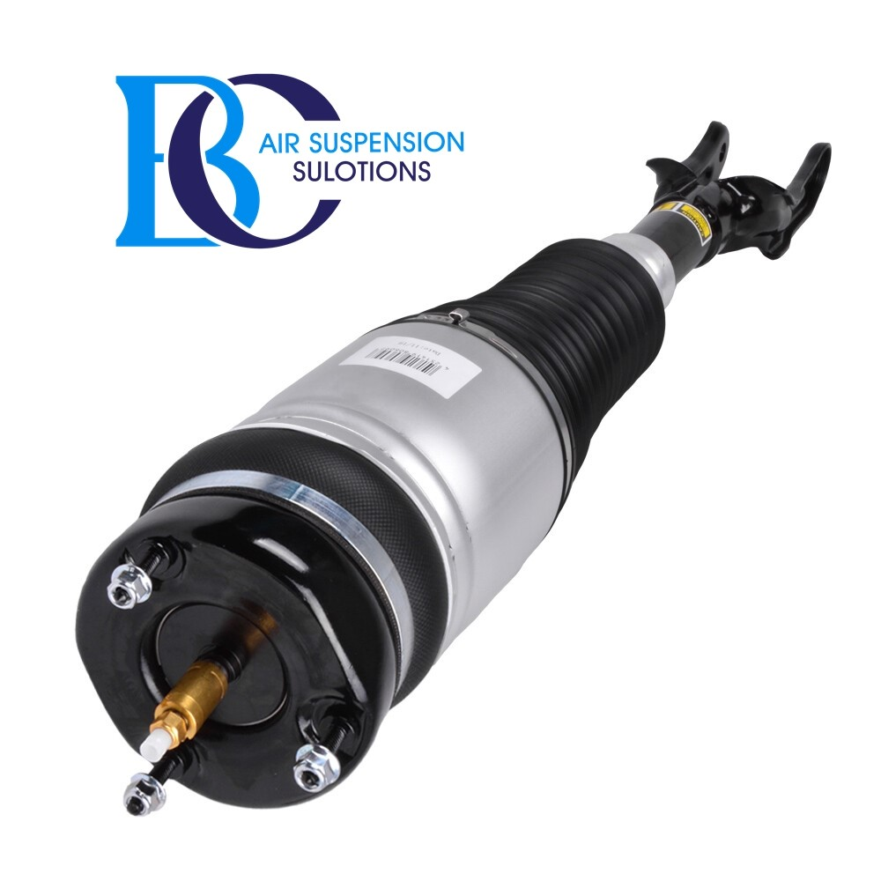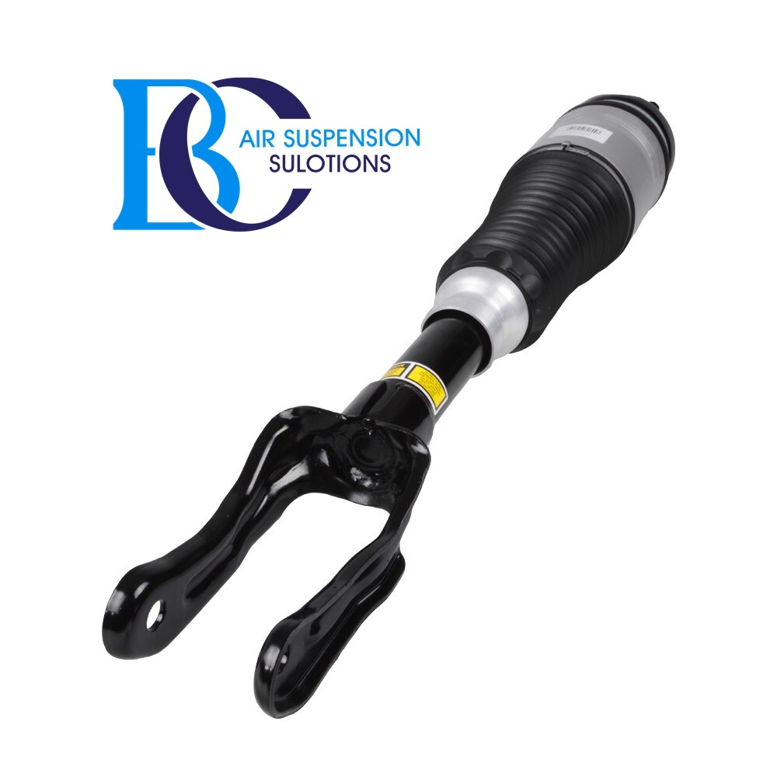

**Description**

This is a new shock absorber Air Suspension Strut front right side.

**Can be installed in the following vehicles:**

JEEP GRAND CHEROKEE Limited 2011-2015

JEEP GRAND CHEROKEE Overland 2011-2015

JEEP GRAND CHEROKEE Summit 2014-2015

JEEP GRAND CHEROKEE Laredo 2011-2015

JEEP GRAND CHEROKEE W5A580 2012-2015

**OEM part number:**

68059904AD, 68059904AB, 68059904AC, 68059904AE, 68029902AB

# **Jeep Grand Cherokee IV Air suspension strut (Front Left)2016+**

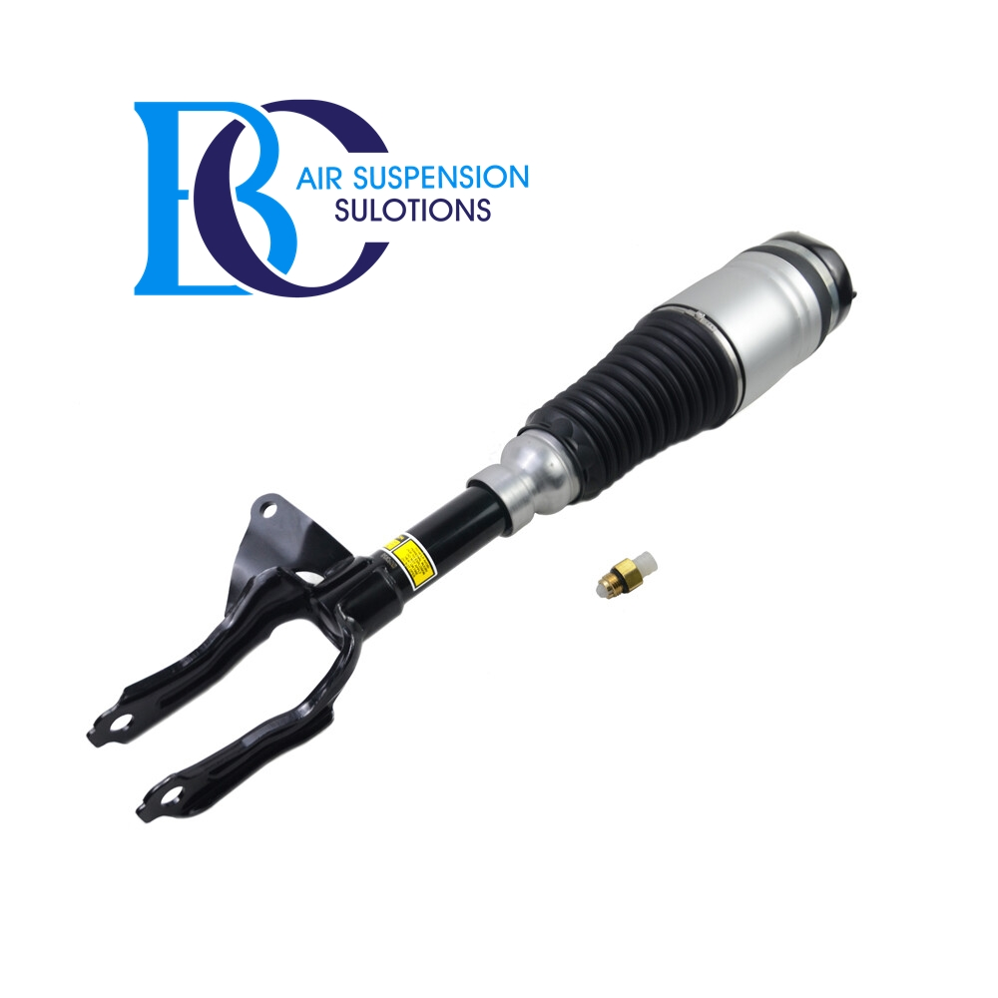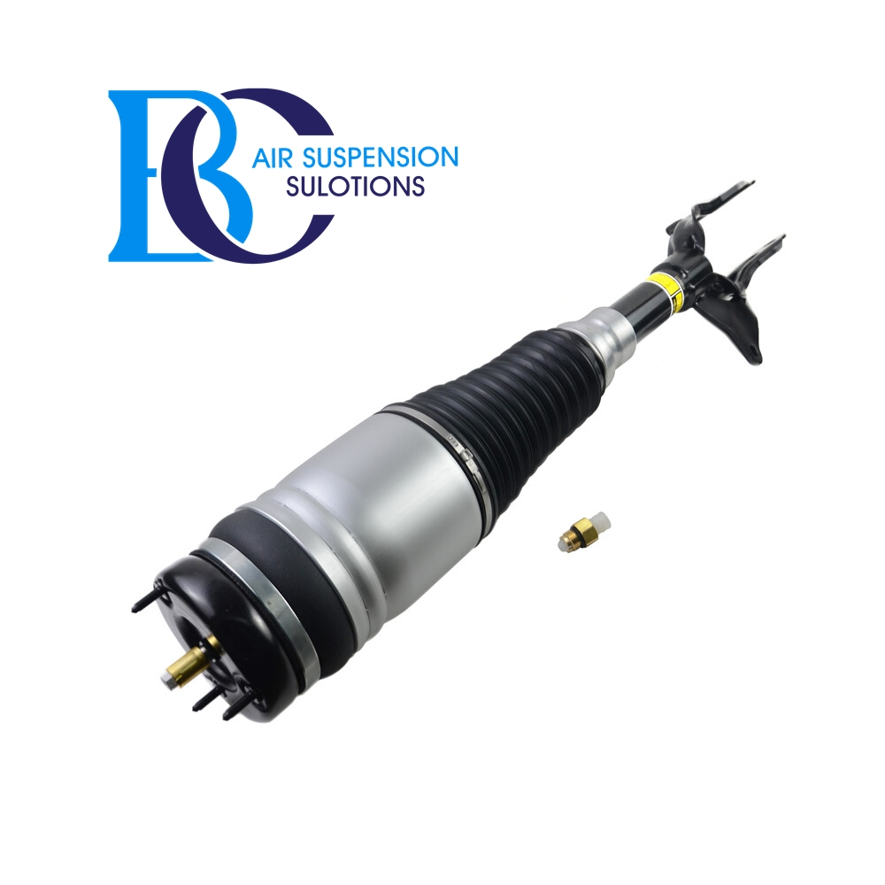

**Description**

This is the front left air strut for Jeep Grand Cherokee 2016 to present.

**Can be installed in the following vehicles:**

JEEP GRAND CHEROKEE Limited 2016-2022

JEEP GRAND CHEROKEE Overland 2016-2022

JEEP GRAND CHEROKEE Summit 2016-2022

JEEP GRAND CHEROKEE Laredo 2016-2022

JEEP GRAND CHEROKEE W5A580 2016-2022

**OEM part number:**

68253204A, 68253204AA, 68253204AB, 68253204AC, 68253204AD, 68253204AE, 68253204AF, 68253204AG

# **Jeep Grand Cherokee IV Air suspension strut (Front Right)2016+**

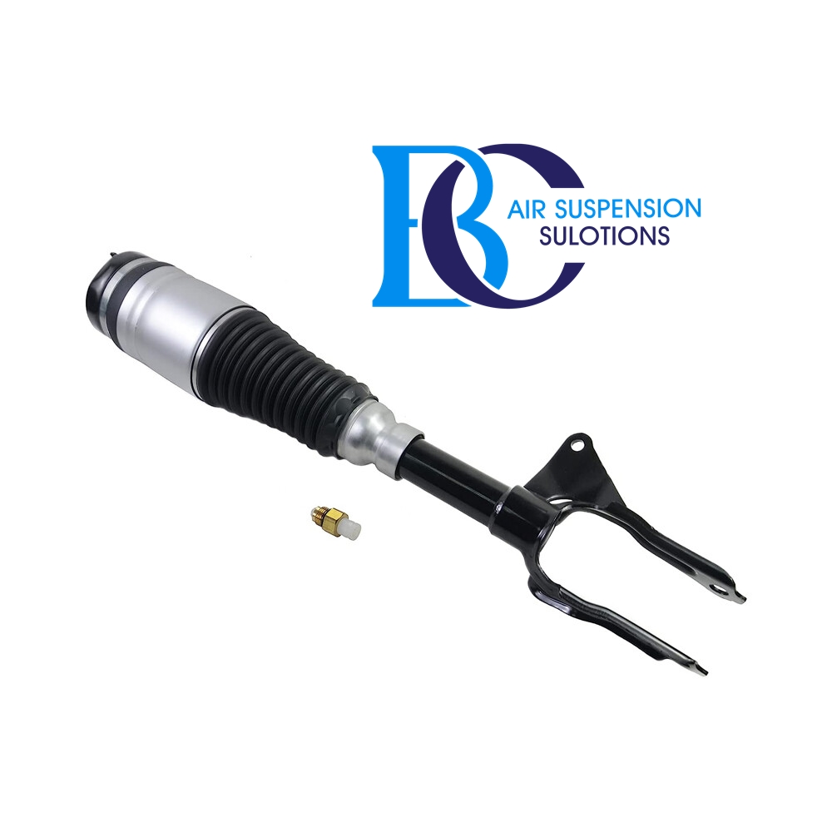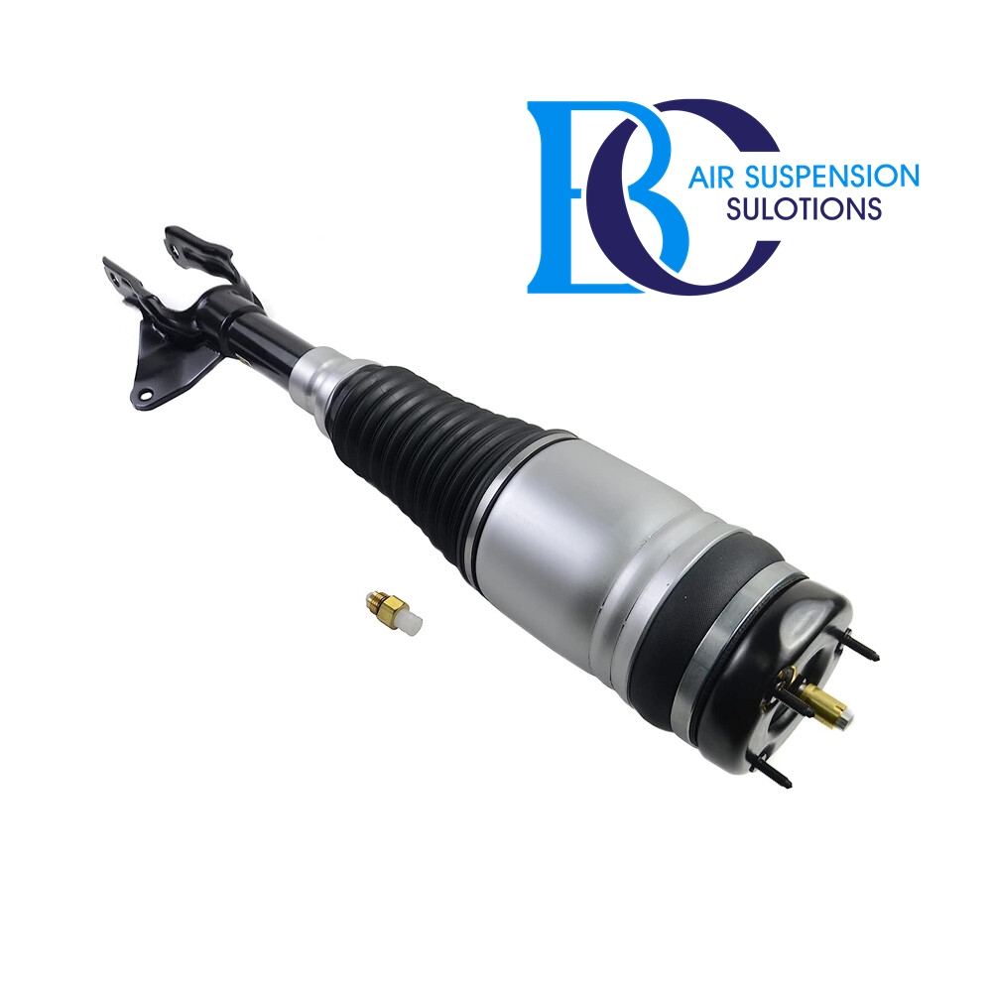

**Description**

This is the front right air strut for Jeep Grand Cherokee 2016 to present.

**Can be installed in the following vehicles:**

JEEP GRAND CHEROKEE Limited 2016-2022

JEEP GRAND CHEROKEE Overland 2016-2022

JEEP GRAND CHEROKEE Summit 2016-2022

JEEP GRAND CHEROKEE Laredo 2016-2022

JEEP GRAND CHEROKEE W5A580 2016-2022

**OEM part number:**

68253205A, 68253205AA, 68253205AB, 68253205AC, 68253205AD, 68253205AE, 68253205AF.

# **JEEP Grand Cherokee air spring air suspension (2010-2015)**

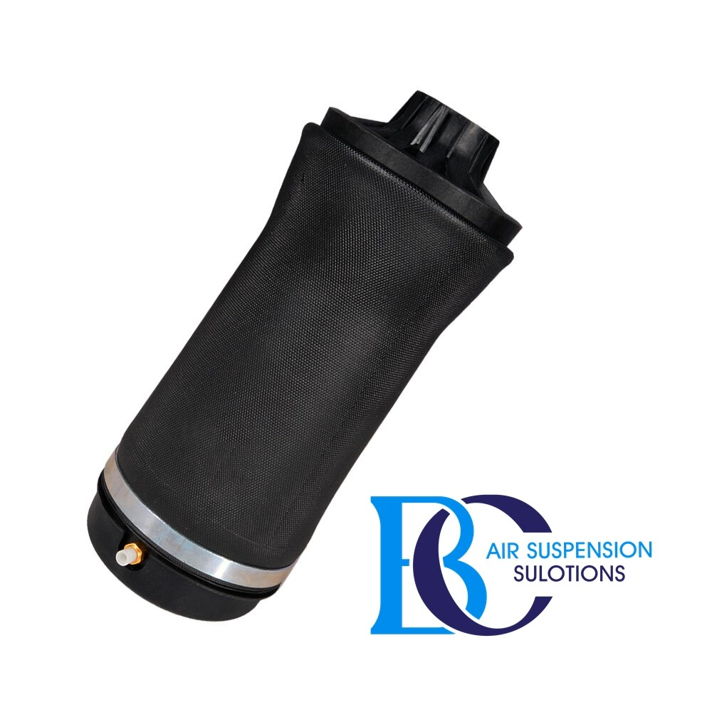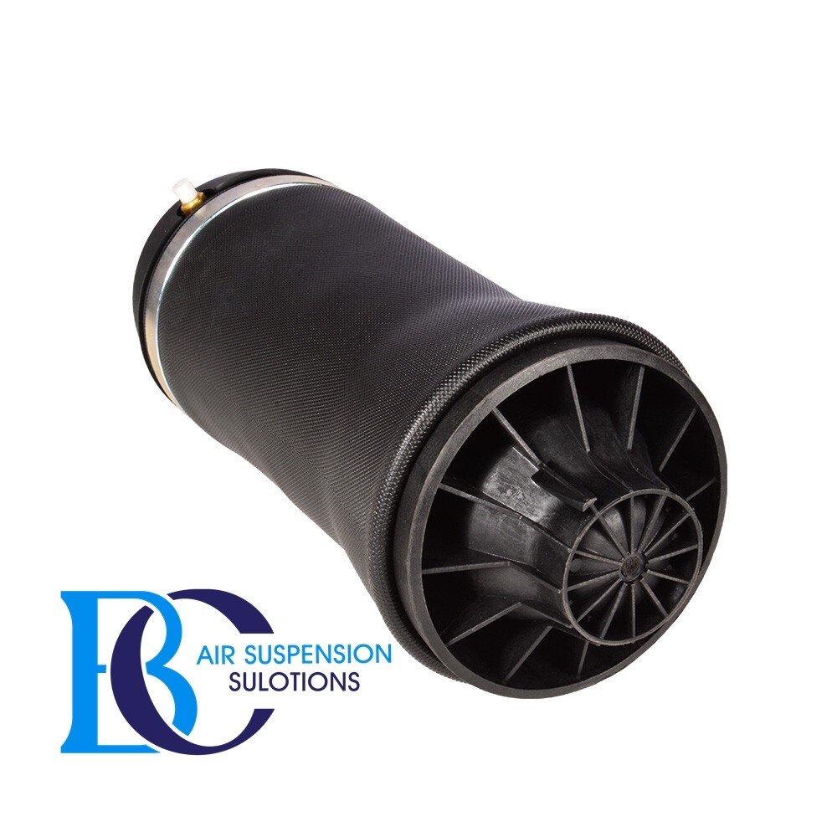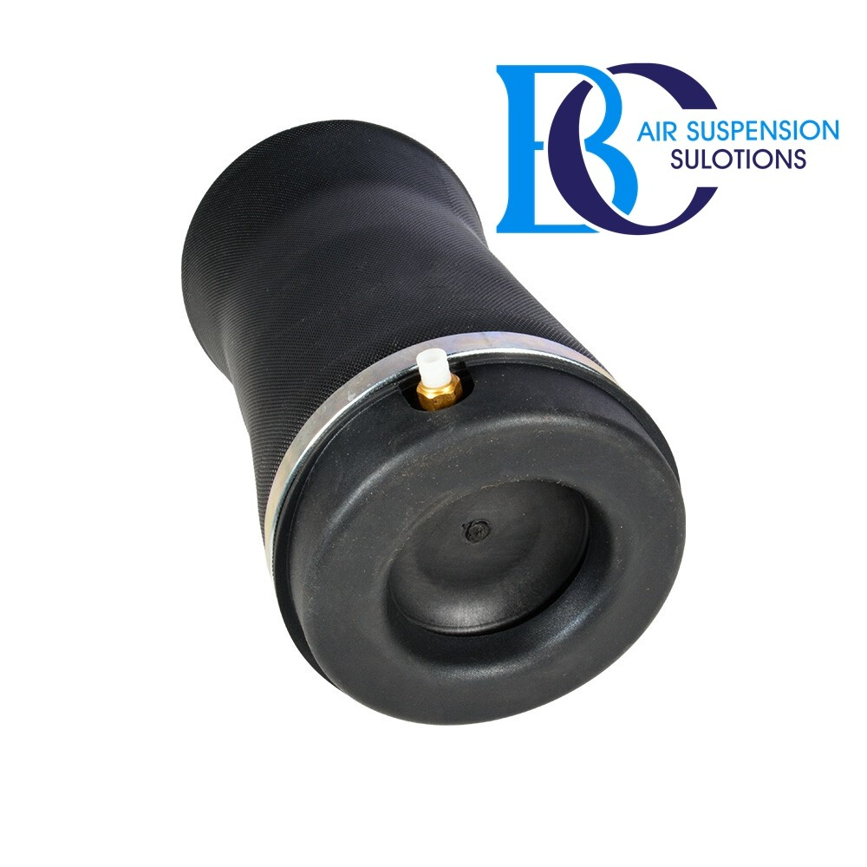

**Description**

This rear air spring for the JEEP Grand Cherokee.

**It Can be installed in the following vehicles:**

JEEP GRAND CHEROKEE Limited 2011-2015

JEEP GRAND CHEROKEE Overland 2011-2015

JEEP GRAND CHEROKEE Summit 2014-2015

JEEP GRAND CHEROKEE Laredo 2011-2015

JEEP GRAND CHEROKEE W5A580 2012-2015

**OEM part numbers:**

68029912AF, 68029911AB, 68029912AC, 68029912AD, 68029912AE, 68029912A

# **Jeep Grand Cherokee Air Spring air suspension Rear 2016+**

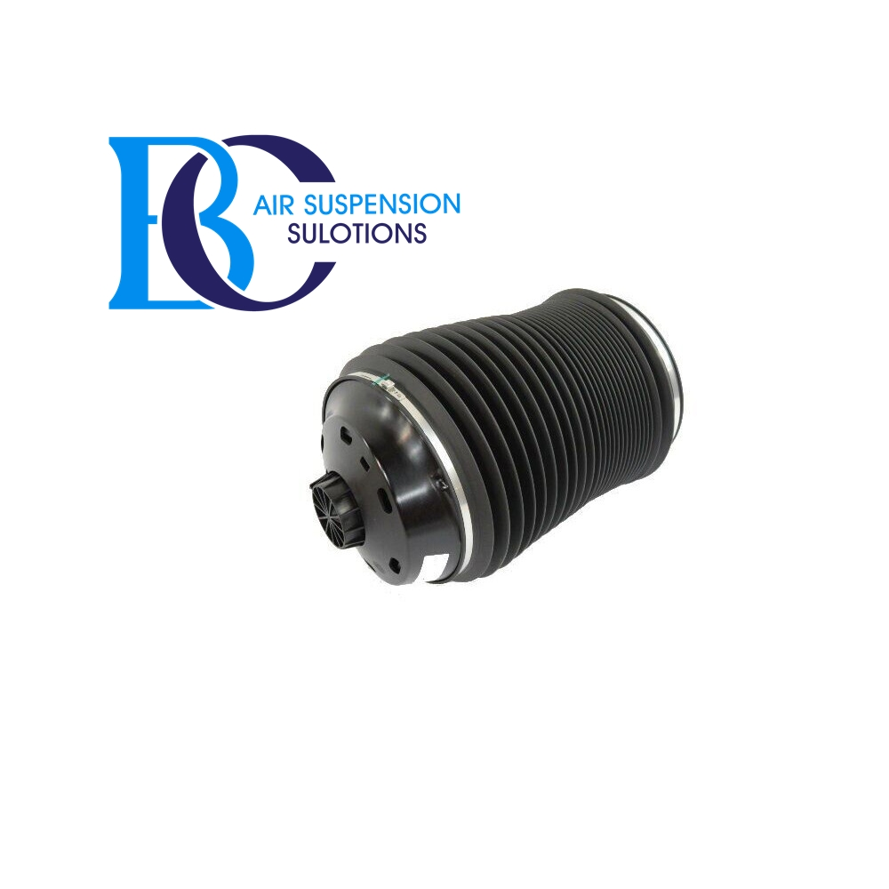

**Description**

This Jeep Grand Cherokee Rear Air Spring.

**It can be installed in the following vehicles:**

Jeep Grand Cherokee (2015--)

**OEM part numbers:**

68258355AC, 68258355AB,68258354AC, 68258354AB.

# **Jeep Grand Cherokee Compressor air suspension**

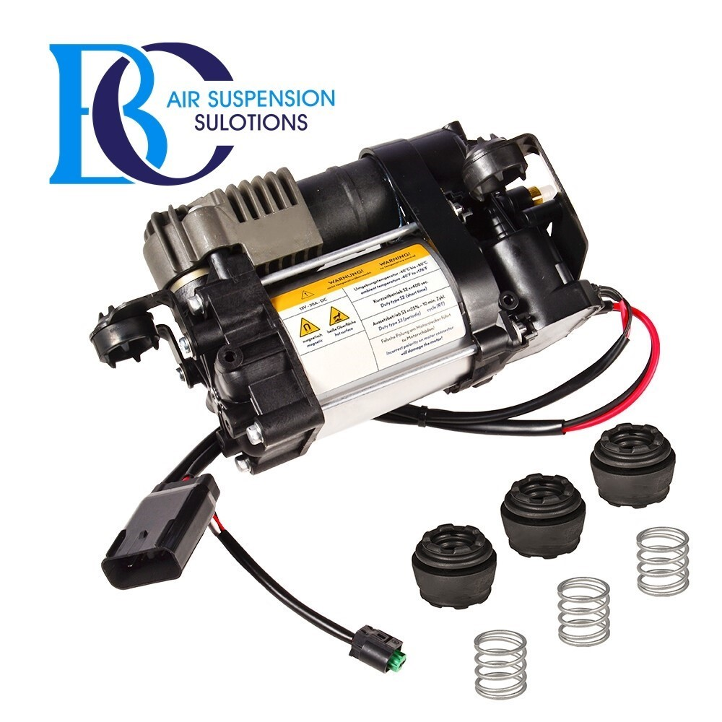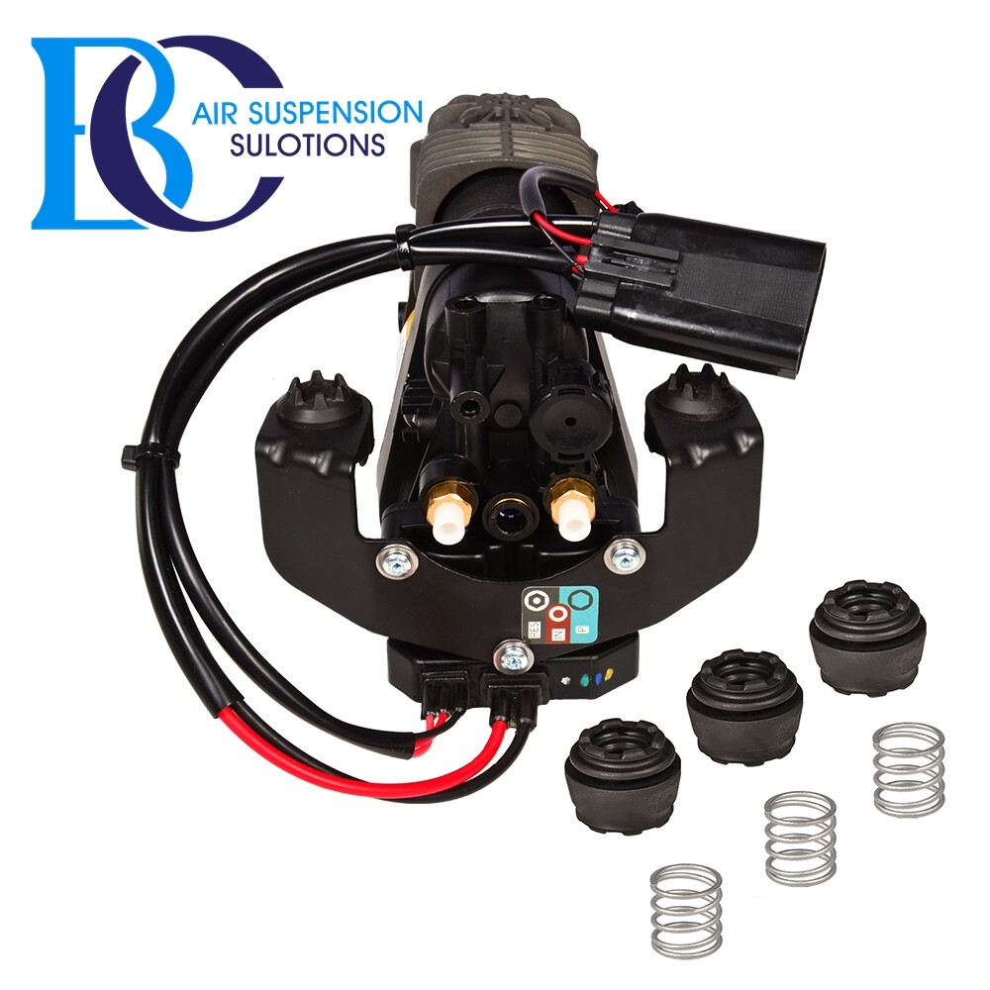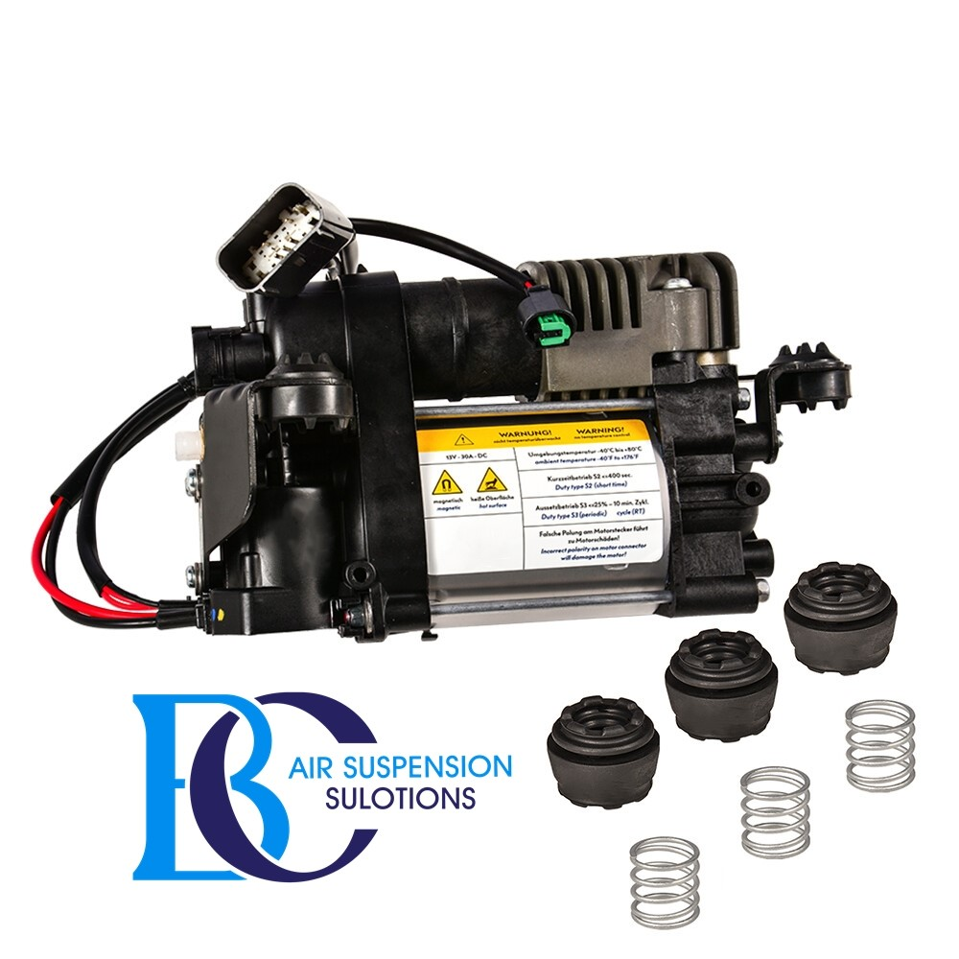

**Description**

This is the compressor for the air suspension of the Jeep Grand Cherokee.

**Can be installed in the following vehicles:**

Jeep Grand Cherokee IV WK, WK2 (2011-2020)

JEEP GRAND CHEROKEE Limited (2011-2018)

JEEP GRAND CHEROKEE Overland (2011-2018)

JEEP GRAND CHEROKEE Summit (2014-2018)

JEEP GRAND CHEROKEE Hemi SRT V8 (2015-2018)

JEEP GRAND CHEROKEE Hemi SRT8 V8 (2012-2014)

**OEM part number:**

68232648AB, 68232648AA

# **JEEP Grand Cherokee Valve unit air suspension**

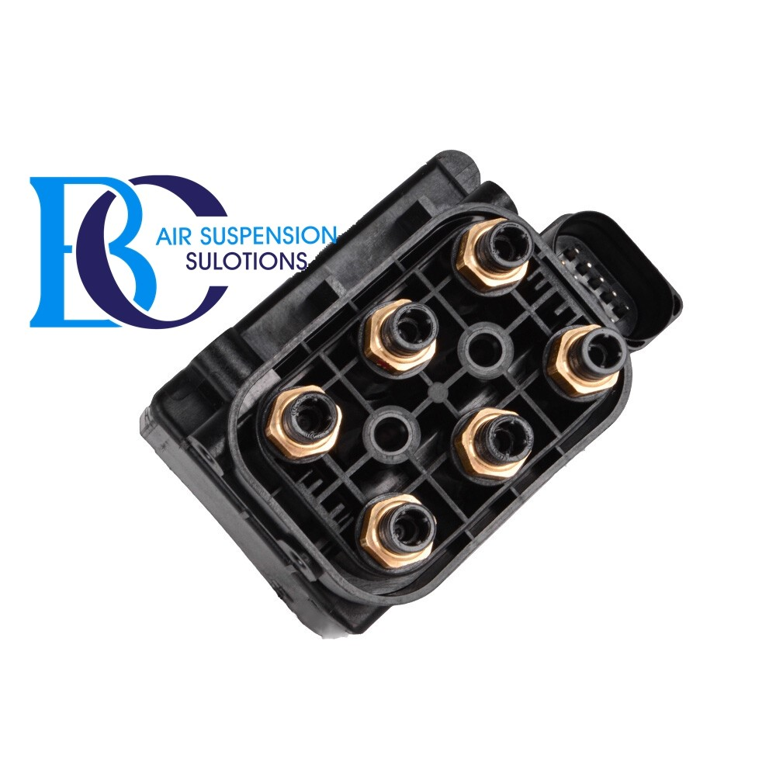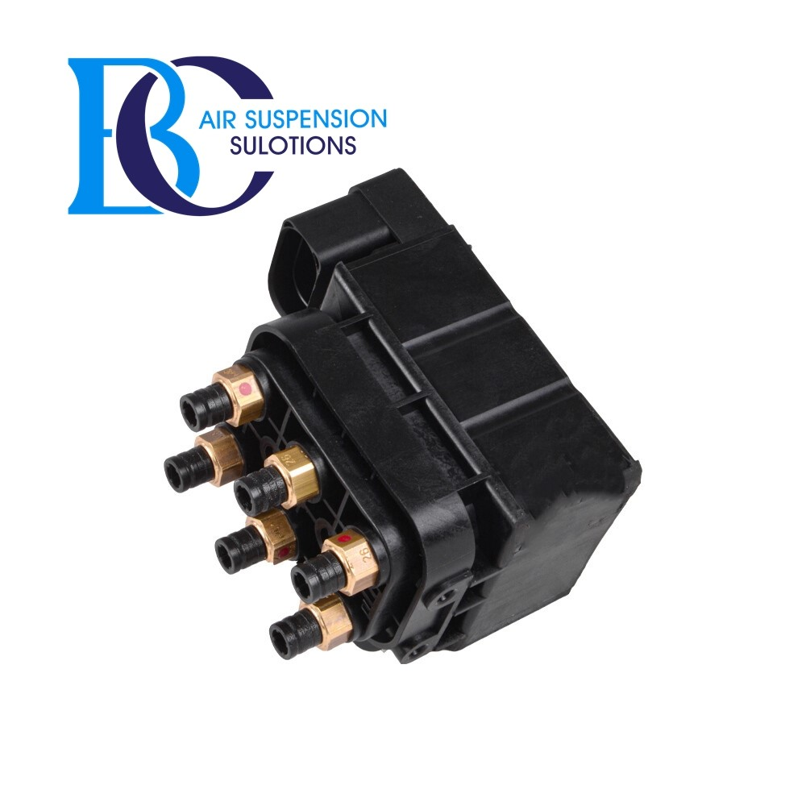

**Description**

This is the control valve for the air suspension of the JEEP Grand Cherokee (2011-2018).

**Can be installed in the following vehicles:**

Jeep Grand Cherokee IV WK, WK2 (2011-2020)

JEEP GRAND CHEROKEE Limited (2011-2018)

JEEP GRAND CHEROKEE Overland (2011-2018)

JEEP GRAND CHEROKEE Summit (2014-2018)

JEEP GRAND CHEROKEE Hemi SRT V8 (2012-2018)

**OEM part numbers:** 68087233AA